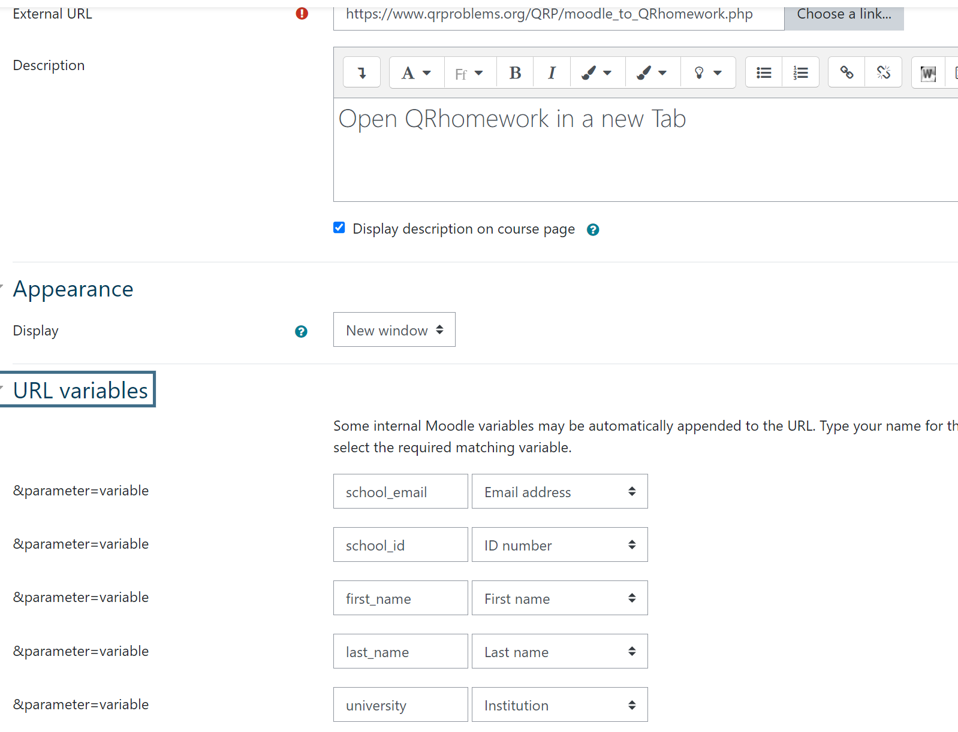

https://www.qrproblems.org/QRP/moodle_to_QRhomework.php

school_email

school_id

first_name

last_name

university